Lab 4 memo

Exercise2:

3. Discuss the interpretation of the coefficients in your model

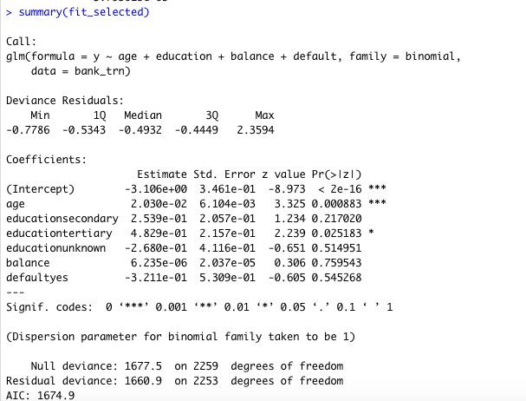

* Age had a positive coefficient (2.03\*10-2), which means an additional year of age expect the chance y=yes increase by 2.03\*10-2. Also, it is a statistically significant since probability(>z) is 0.000883 < 0.005.
* Education secondary had a positive coefficient (2.539\*10-1), which means an additional education secondary level expect the chance of y= yes increase by 2.539\*10-1. Also, it is not a statistically significant since probability(>z) is 0.21702 > 0.005.
* Education tertiary had a positive coefficient (4.829\*10-1), which means an additional education tertiary level expect the chance of y=yes increase by 4.829\*10-1. Also, t is not a statistically significant since the probability(>z) is 0.025183 > 0.005.
* Balance has a positive coefficient (6.235\*10-6), which means an additional balance expected the chance of y=yes increase by 6.235\*10-6. Also, it is not a statistically significant since the probability(>z) is 0.759543 > 0.005.
* Default had a negative coefficient (-3.211\*10-1), which means an additional default expected the chance of y=no increase by -3.211\*10-1. also, it is not a statistically significant since the probability(>z) is 0.545268 > 0.005.